**ARDUINO MPU 6050 – BEST IMU SENSOR TUTORIAL**

[8](http://diyhacking.com/arduino-mpu-6050-imu-sensor-tutorial/)

[240](http://diyhacking.com/arduino-mpu-6050-imu-sensor-tutorial/#comments)

[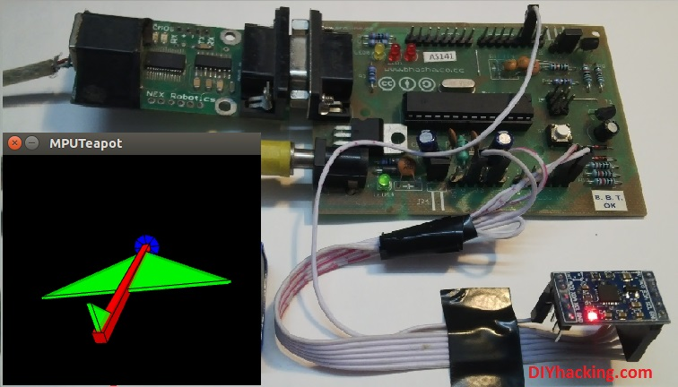](http://301o583r8shhildde3s0vcnh.wpengine.netdna-cdn.com/wp-content/uploads/2014/11/Newcover.jpg)

Arduino MPU 6050 Tutorial

In this post, I will be reviewing a few basic IMU (Inertia Measurement Unit) sensors, compatible with arduino. I shall also give a short tutorial for interfacing arduino with the best IMU sensor available. IMU sensors like the MPU 6050 are used in self balancing robots, UAVs, smartphones, etc.

IMU sensors are one of the most inevitable type of sensors used today in all kinds of electronic gadgets. They are seen in smartphones, wearables, game controllers, etc. IMU sensors help us in getting the attitude of an object, attached to the sensor in three dimensional space. These values usually in angles, thus help us to determine its attitude. Thus, they are used in smartphones to detect its orientation. And also in wearable gadgets like the nike fuel band or fit bit, which use IMU sensors to track movement.

IMU sensors, thus have prolific number of applications. It  is even considered to be an inexorable component in quadrotors. So use this Arduino MPU 6050 tutorial to build a self balancing robot or a hand tracking device . Some of the sensors that I was able to get my hands on were:

1. ADXL 345 accelerometer.
2. ITG 3200 gyroscope.
3. Sparkfun 6 DOF IMU sensor board.
4. MPU 6050.

I was able to work with both accelerometers and gyroscopes separately. However, they are not as accurate as when they are combined.  And among the lot, I found the Invensense MPU 6050 to be the most reliable and accurate IMU sensor. Apart from being significantly cheap from the other sensors, the MPU 6050 performs much better too.

[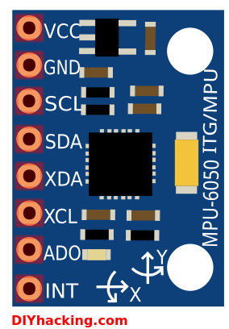](http://301o583r8shhildde3s0vcnh.wpengine.netdna-cdn.com/wp-content/uploads/2014/11/mpu6050.png)

Arduino MPU 6050 Pin out

In this tutorial, I shall give you a basic introduction to the MPU 6050, demonstrate how it can be interfaced to an arduino. And show you to make a 3D model using the data from Arduino MPU 6050.

**What are the stuff required to do this project?**

**Hardware:**

1. [Arduino](http://robokits.co.in/shop/index.php?main_page=product_info&cPath=6_72&products_id=388" \t "_blank) or an arduino clone board ([freeduino](http://robokits.co.in/shop/index.php?main_page=product_info&cPath=6_72&products_id=388" \t "_blank)). Or make your own custom arduino board with this [tutorial.](http://diyhacking.com/make-arduino-board-and-bootload/" \t "_blank)
2. [MPU 6050](http://www.ebay.in/itm/like/261646571375" \t "_blank) sensor.
3. Interconnecting wires.

**Software:**

1. Arduino IDE: [Arduino](http://arduino.cc/en/main/software)
2. Processing IDE : [Processing](https://processing.org/download/?processing" \t "_blank) (optional)

**How does it work?**

IMU sensors usually consists of two or more parts. Listing them by priority, they are : accelerometer, gyroscope, magnetometer and altimeter. The MPU 6050 is a 6 DOF (Degrees of Freedom) or a six axis IMU sensor, which means that it gives six values as output. Three values from the accelerometer and three from the gyroscope. The MPU 6050 is a sensor based on MEMS (Micro Electro Mechanical Systems) technology. Both the accelerometer and the gyroscope is embedded inside a single chip. This chip uses I2C (Inter Integrated Circuit) protocol for communication.

How does an accelerometer work?

[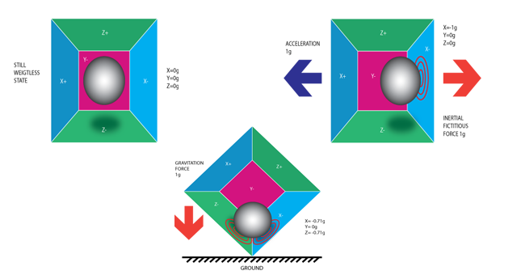](http://301o583r8shhildde3s0vcnh.wpengine.netdna-cdn.com/wp-content/uploads/2014/11/acc.png)

Piezo Electric Accelerometer

An accelerometer works on the principle of piezo electric effect. Here, imagine a cuboidal box, having a small ball inside it, like in the picture above. The walls of this box are made with piezo electric crystals. Whenever you tilt the box, the ball is forced to move in the direction of the inclination, due to gravity. The wall with which the ball collides, creates tiny piezo electric currents. There are totally, three pairs of opposite walls in a cuboid. Each pair corresponds to an axis in 3D space: X, Y and Z axes. Depending on the current produced from the piezo electric walls, we can determine the direction of inclination and its magnitude. For more information check [this](http://en.wikipedia.org/wiki/Accelerometer).

How does a gyroscope work?

[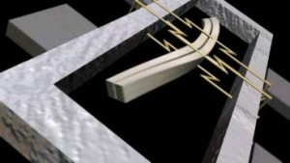](http://301o583r8shhildde3s0vcnh.wpengine.netdna-cdn.com/wp-content/uploads/2014/10/gyro-1024x576.jpg)

Piezo Electric Gyroscope

Gyroscopes work on the principle of Coriolis acceleration. Imagine that there is a fork like structure, that is in constant back and forth motion. It is held in place using piezo electric crystals. Whenever, you try to tilt this arrangement, the crystals experience a force in the direction of inclination. This is caused as a result of the inertia of the moving fork. The crystals thus produce a current in consensus with the piezo electric effect, and this current is amplified. The values are then refined by the host microcontroller. Now check this short [video](https://www.youtube.com/watch?v=zwe6LEYF0j8) that explains, how a MEMS gyroscope works.

**Step 1: Interfacing the Arduino MPU 6050**

The MPU 6050 communicates with the Arduino through the I2C protocol. The MPU 6050 is connected to Arduino as shown in the following diagram. Here, if your MPU 6050 module has a 5V pin, then you can connect it to your arduino’s 5V pin. Else, you will have to connect it to the 3.3V pin. Next, the GND of the arduino is connected to the GND of the MPU 6050.

[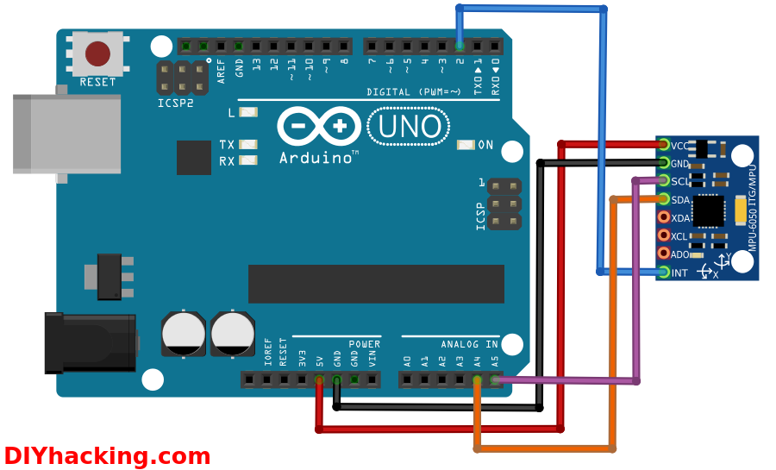](http://301o583r8shhildde3s0vcnh.wpengine.netdna-cdn.com/wp-content/uploads/2014/11/conn.png)

Arduino MPU 6050 connections

The program we will be running here, also takes advantage of the arduino’s interrupt pin. Therefore, connect arduino’s digital pin 2 (interrupt pin 0) to the pin labelled as INT on the MPU 6050. Next, we need to set up the I2C lines. For this connect the pin labelled as SDA on the MPU 6050 to the arduino’s analog pin 4 (SDA). And the pin labelled as SCL on the MPU 6050 to the arduino’s analog pin 5 (SCL). And that’s it, you have finished wiring up the Arduino MPU 6050.

**Step 2: Uploading the code and testing the Arduino MPU 6050**

To test the Arduino MPU 6050, first download the arduino library for MPU 6050, developed by Jeff Rowberg. You can find the library [here](http://diyhacking.com/projects/MPU6050.zip" \t "_blank). Next you have to unzip/extract this library. And then take the folder named “MPU6050” and paste it inside the arduino’s “library” folder. That is, go to the location where you have installed arduino (Arduino –> libraries) and paste it inside the libraries folder. You might also have to do the same thing to install the I2Cdev library as well, if you don’t already have it for your arduino. Do the same procedure as above for installing it, you can find the file here: [I2Cdev](http://diyhacking.com/projects/I2Cdev.zip) library.

If you have done this correctly, then when you open the arduino IDE, you can see “MPU6050” in File –> Examples. Next, open the example program from: File –> Examples –> MPU6050 –> Examples –> MPU6050\_DMP6.

[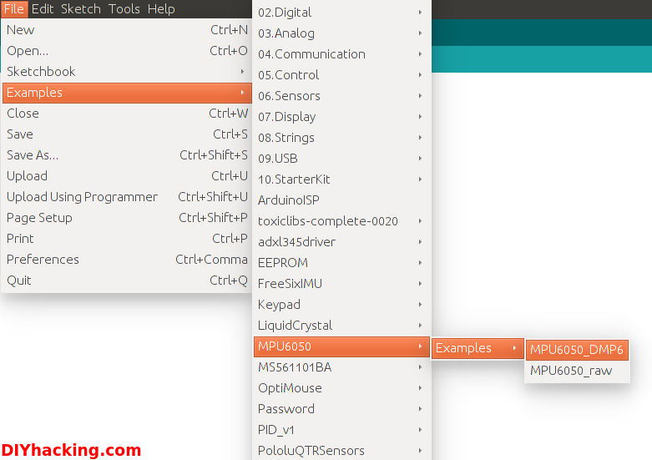](http://301o583r8shhildde3s0vcnh.wpengine.netdna-cdn.com/wp-content/uploads/2014/11/arduinoCode.png)

Arduino MPU 6050 DMP code

Now, you have to upload this code to arduino. After uploading the code, open up the serial monitor and set the baud rate as 115200. Next, check if you see stuff like “Initializing I2C devices…” on the serial monitor. If you don’t, just press the reset button. Now, you’ll see a line saying  “Send any character to begin DMP programming and demo: “. So just type in any character on the serial monitor and send it. And you will start seeing the yaw, pitch and roll values coming in from the MPU 6050. Like so:

[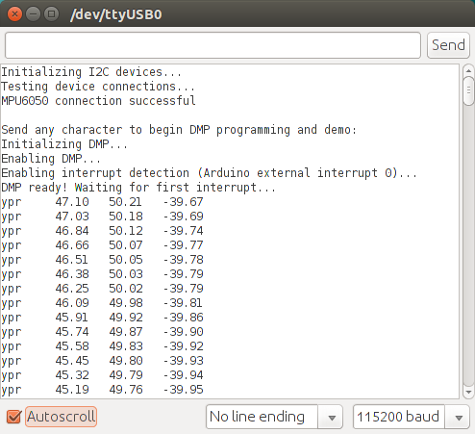](http://301o583r8shhildde3s0vcnh.wpengine.netdna-cdn.com/wp-content/uploads/2014/11/mpuSerial.png)

Arduino MPU 6050 Serial Monitor

DMP stands for Digital Motion Processing. Here, the Invense’s MPU 6050 has an inbuilt motion processor. It processes the values from the accelerometer and gyroscope to give us accurate 3D values.

Also, you will need to wait about 10 secs before you get accurate values from the Arduino MPU 6050. After which, the values will begin to stabilize. Just check out the video, if you have any doubts:

**Step 3: Modelling the values from Arduino MPU 6050 in 3D using processing (Optional)**

If you want to see the 3D model of the sensor, continue reading. For viewing the 3D representation of the data from the MPU 6050, you need to install the “processing” software, you can do that from here: [processing](https://processing.org/download/?processing) IDE. Processing is almost similar to arduino, except for a couple of functions. Processing is mainly used for visualizing data and rendering it in 2D/3D models.

[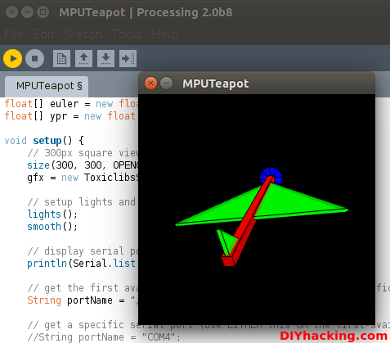](http://301o583r8shhildde3s0vcnh.wpengine.netdna-cdn.com/wp-content/uploads/2014/11/process.png)

Arduino MPU 6050 with Processing

After installing the processing IDE, next you will need to download a library called “Toxi”. This library is necessary for our Arduino MPU 6050 processing example. Download the latest zip file for the library from [here](http://hg.postspectacular.com/toxiclibs/downloads/). Next, you need to extract this file and paste the folder named “toxiclibs-complete-0020” in the libraries directory of processing. You can find the “libraries” folder inside the Sketchbook folder of processing. If you don’t, then you will have to create a new folder called “libraries” there, and paste the toxiclibs inside it.

To visualize the 3D model in processing, first you have to upload the  arduino code for MPU 6050 (MPU6050\_DMP6). Before doing that, you need to comment the line in the arduino MPU6050\_DMP6 code which says:

#define OUTPUT\_READABLE\_YAWPITCHROLL  by  //#define OUTPUT\_READABLE\_YAWPITCHROLL.

And uncomment the line which says:

//#define OUTPUT\_TEAPOT  by  #define OUTPUT\_TEAPOT.

Next, you have to open the processing example for the MPU 6050. Open processing, then: File –> Open. And then navigate to the folder where you had installed the MPU6050 library for arduino. You can find the processing example in: MPU6050 –> Examples –> MPU6050\_DMP6 –> Processing –> MPUTeapot.

In this code, you have to then check the serial port which is defined in it. By default the line that defines it for linux/mac users is like:

String portName = “/dev/ttyUSB1”;.

You need to change ttyUSB1 to the port on which your arduino is connected.

[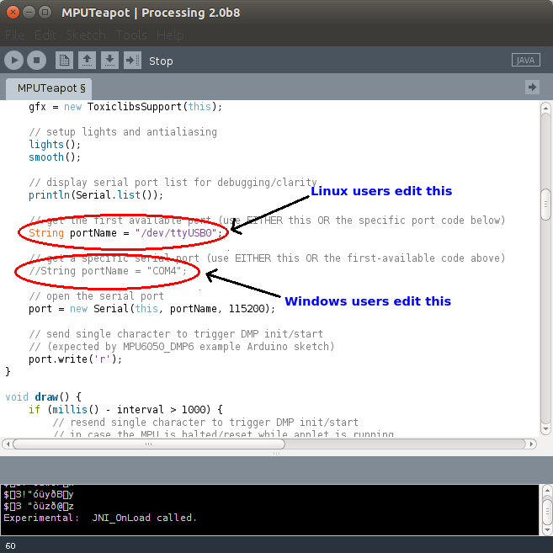](http://301o583r8shhildde3s0vcnh.wpengine.netdna-cdn.com/wp-content/uploads/2014/11/processCode.png)

Editing the Processing file for MPU 6050

And for windows users, you need to comment the line which says:

String portName = “/dev/ttyUSB1”;  by  //String portName = “/dev/ttyUSB1”;.

And uncomment the line which says:

//String portName = “COM4”;  by  String portName = “COM4”;.

And replace “COM4” with the COM port on which your arduino is connected (check this by going into arduino and Tools –> Serial Port).

Now we can test the whole setup. First upload the arduino code (MPU6050\_DMP6) through arduino. And please remember NOT to open the serial monitor. Next run the processing code (MPUTeapot) by pressing the button with the “play” symbol. You will see a small plane like object. Wait for about 10 secs for the MPU 6050 values to get stabilized. After, which you can see the 3D model of your MPU 6050, which moves accordingly with the sensor. Now, check out the demo for the Arduino MPU 6050 3D model